|  |  |  |  |  |  |  |  |  |  |  |  |  |  |  |  |  |  |  |  |  |  |  |  |
| --- | --- | --- | --- | --- | --- | --- | --- | --- | --- | --- | --- | --- | --- | --- | --- | --- | --- | --- | --- | --- | --- | --- | --- |
|  | **2** | **3** | **4** | **5** | **6** | **7** | **8** | **9** | **10** | **11** | **12** | **13** | House**14** | House**15** | **16** | **17** | **18** | **19** | **20** | **21** | **22** | **23** | **24** |
| ***1*** |  |  |  |  |  |  |  |  |  |  |  |  | HouseHouse |  |  | Farm scene |  | Farm scene |  |  |  |  |  |
| ***2*** |  |  |  |  |  |  |  |  |  |  |  |  |  |  |  |  |  |  |  |  |  |  |  |
| ***3*** |  |  |  |  |  |  |  |  |  |  |  |  |  |  |  |  |  |  |  |  |  |  |  |
| ***4*** |  |  |  |  |  |  |  |  |  |  |  |  |  |  |  |  |  |  |  |  |  |  |  |
| ***5*** |  |  |  |  |  |  |  |  |  |  |  |  |  |  |  |  |  |  |  |  |  |  |  |
| ***6*** |  |  |  |  |  |  |  |  |  |  |  |  |  |  |  |  |  |  |  |  |  |  |  |
| ***7*** |  |  |  |  |  |  |  |  |  |  |  |  |  |  |  |  |  |  |  |  |  |  |  |
| ***8*** |  |  |  |  |  |  |  |  |  |  |  |  |  |  |  |  |  |  |  |  |  |  |  |
| ***9*** |  |  |  |  |  |  |  |  |  |  |  |  |  |  |  |  |  |  |  |  |  |  |  |
| ***10*** |  |  |  |  |  |  |  |  |  |  |  |  |  |  |  |  |  |  |  |  |  |  |  |
| ***11*** |  |  |  |  |  |  |  |  |  |  |  |  |  |  |  |  |  |  |  |  |  |  |  |
| ***12*** |  |  |  |  |  |  |  |  |  |  |  |  |  |  |  |  |  |  |  |  |  |  |  |

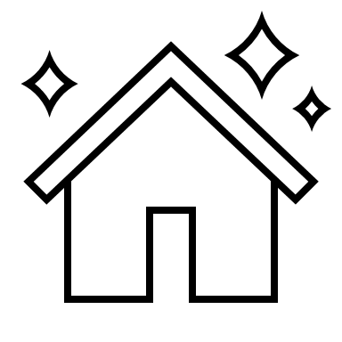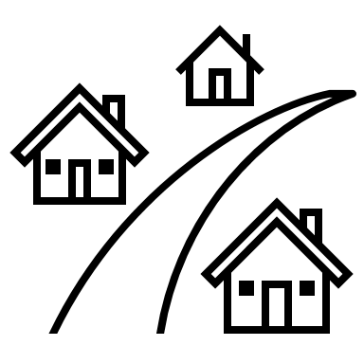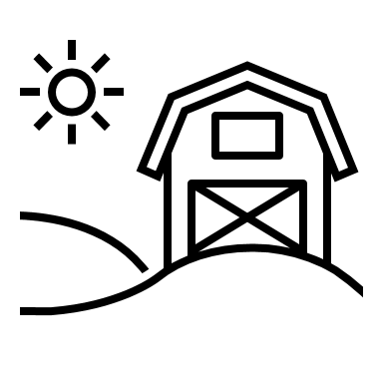

*\*Wells 1 and 25 are not included due to space limitation.*