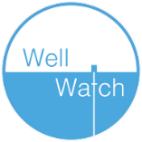

**_____________________________**

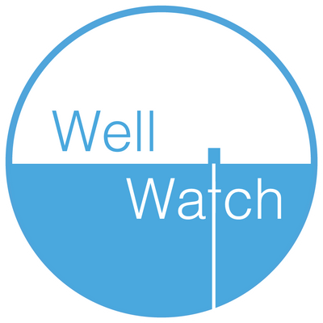

**Well Watch – Sustainability Binder**



